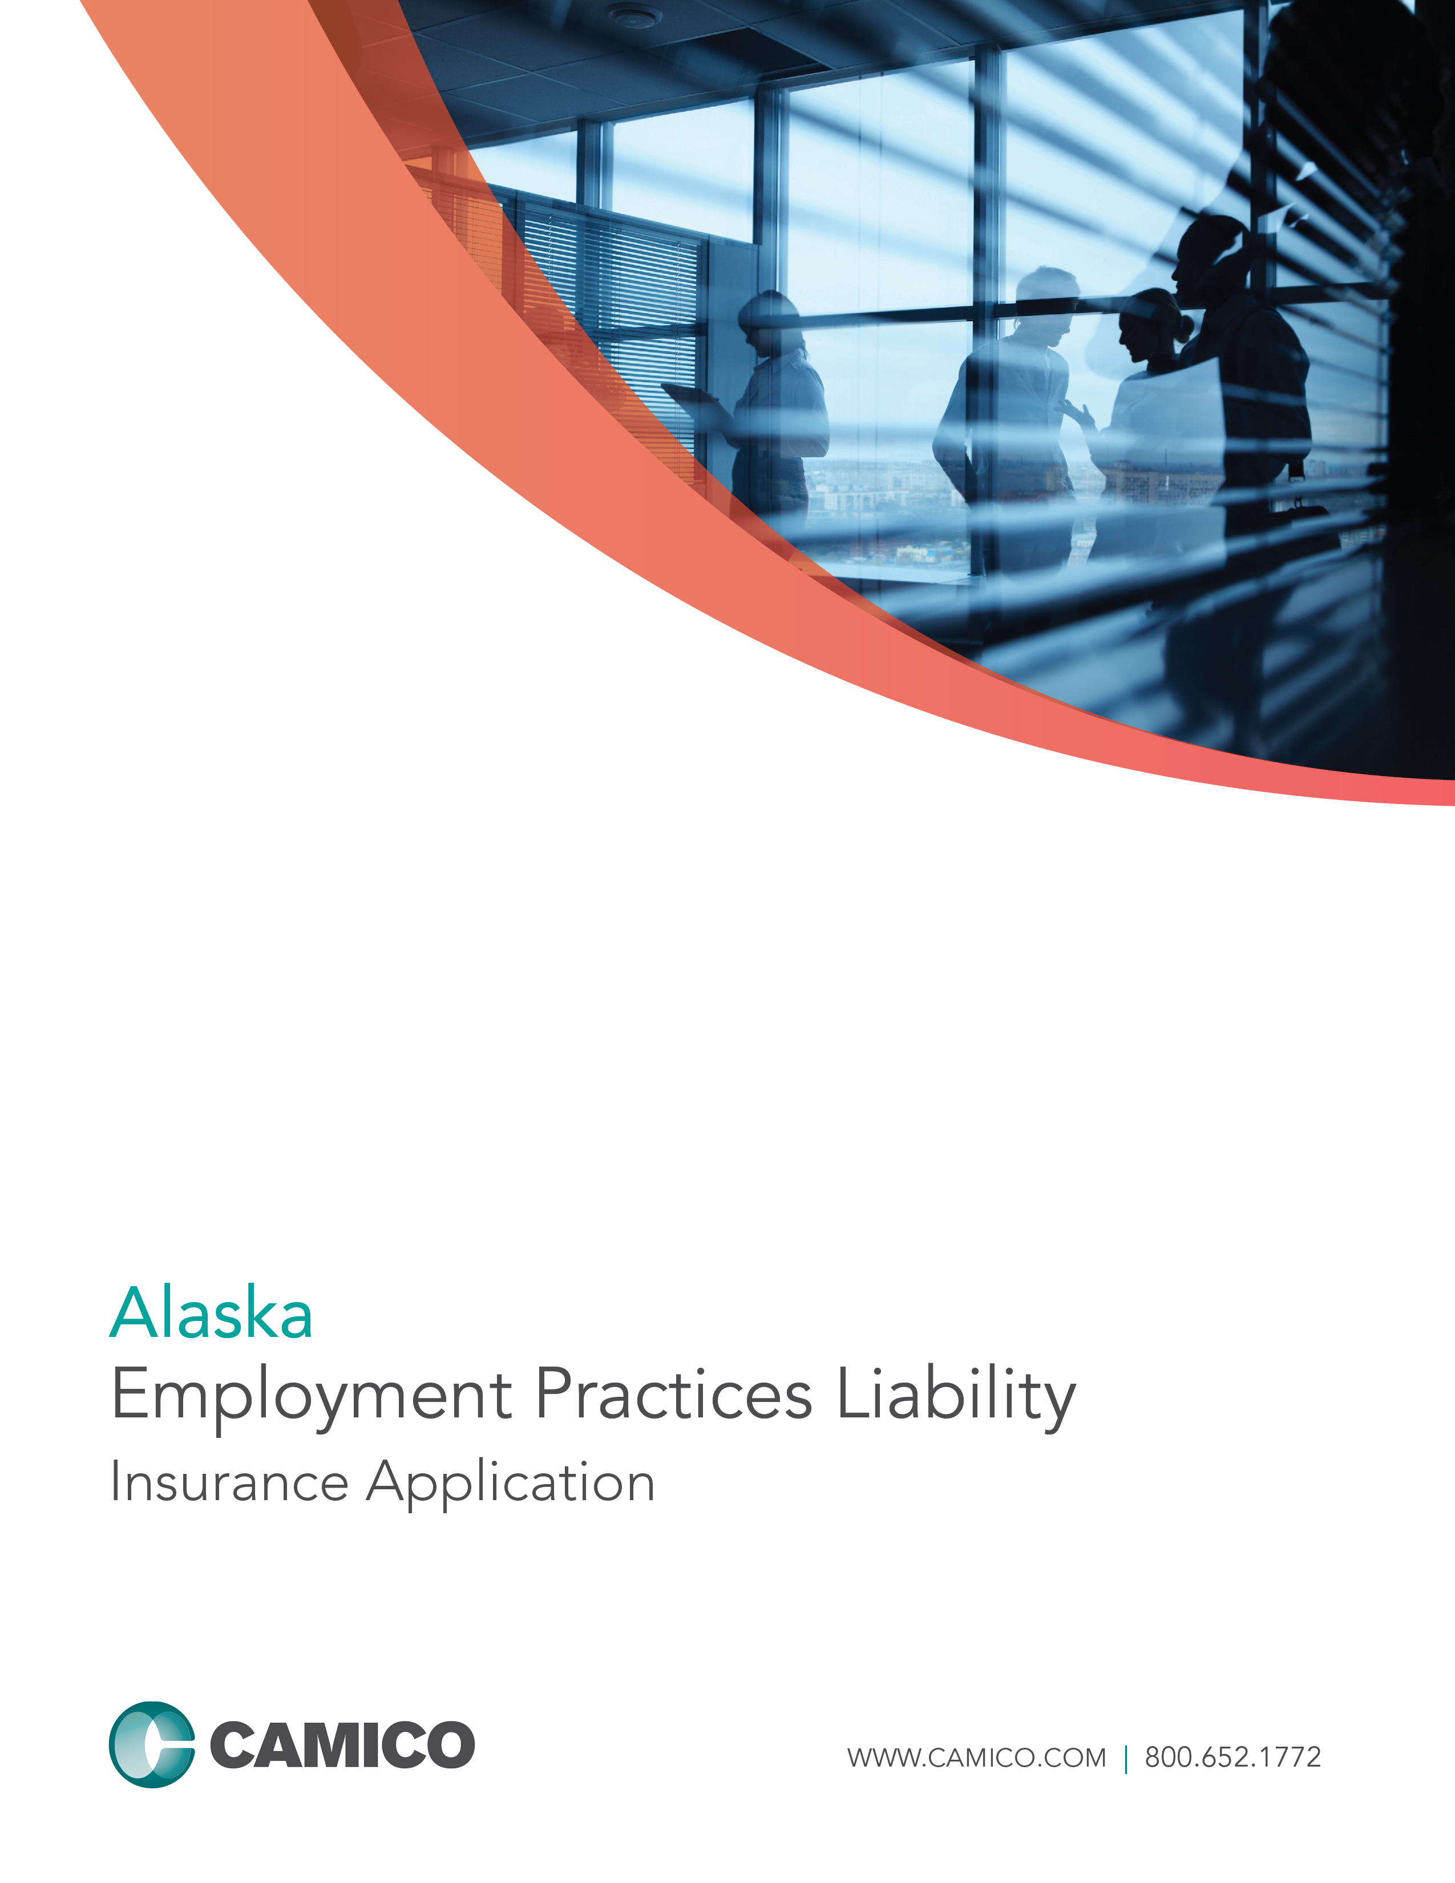

EMPLOYMENT PRACTICES LIABILITY INSURANCE APPLICATION
This is an application for a “Claims Made and Reported” policy. The policy applies only to employment practices claims first made against the Insured and reported to the Company while the policy is in force or during any applicable extended reporting period and for employment practices occurring after the prior acts date. The limit of liability available to pay damages or settlements shall be reduced by amounts incurred as “Claim Expenses,” including fees and expenses incurred in the investigation, adjustment, and defense of a claim or multiple claims. The policy will be issued in reliance upon the statements in the application. Therefore, it is important that all questions be answered accurately.
Please follow the steps listed below to complete your application for CAMICO coverage:
- Review all definitions at the bottom of the page.
- Please type or print clearly, and do not use pencil.
- Complete Parts I through VII, answering all questions completely. If any question, or part thereof, does not apply, print “NA” in the space provided - leave no blanks. Failure to answer all questions will delay our ability to underwrite this application, which may result in a gap in your coverage.
- Complete supplemental application(s) only when appropriate.
- Sign on page 6 and make a copy of the completed application for your records.
- Return the completed application (see page 6 for mailing address).

Common Phrases and Definitions
FIRM
The term “Firm” means the entity listed in Part I, question 1 of this application and any individual owner (proprietor, stockholder, partner) and any individual employee of the entity listed in Part I, question 1 of this application.
PRIOR ACTS
Coverage for employment practices prior to inception of this policy may be requested where the Firm has current employment practices liability coverage.
If this policy is written with prior acts coverage it shall apply only to claims for damages as a result of employment practices which first take place on or after the prior acts (retroactive) date.
PART-TIME
Persons who work more than 32 hours per week or 1,600 hours per year, even if seasonal, are Full-Time. Persons who work less than 32 hours per week or 1,600 hours per year are considered Part-time.
Part I: Firm Information
1. Firm Name:
2. Contact Person: 3. Requested Effective Date:
4. Title: 5. E-mail Address:
6. Primary Office Address:
Street Address City County State Zip
If your Firm operates from any other office location(s), please complete Part I, Question 6, of the EPL Insurance Supplement (E-1).
7. Telephone: 8. Fax: 9. Web Site:
10. Mailing Address:
(if different from #6) Street Address City County State Zip
11. Entity Type: Sole Proprietorship Partnership Corporation LLP LLC PC Other (list):
12. Date Firm Established (mm/dd/yyyy):
13. List Name(s) of all Partners/Owners.
Name | % Ownership | Title | Professional Organization Memberships | E-mail Address
Please use Part I, Question 13, of the EPL Insurance Supplement (E-1) if additional room is needed.

Part II: Firm Profile
14. For the location listed above in Question 6, please list the total number of employees, workers and independent contractors, broken down by Full-Time employees, Part-Time employees, Contract Workers, Leased Workers and Independent Contractors, for each of the last three years (please refer to explanation of staff types below):
If your Firm operates from any other office location(s), please complete Part II, Question 14, of the EPL Insurance Supplement (E-1).
PLEASE DO NOT INCLUDE PARTNERS IN THE FIRM
 | Current Year | Prior Year | 2 Years Ago
# of Full-Time Employees
# of Part-Time Employees
# of Contract Workers
# of Leased Workers
# of Independent Contractors
Total
15. CAMICO’s Employment Practices Liability Insurance does not include coverage for Independent Contractors unless this coverage is added by endorsement. Please check the “Yes” box if you want to add coverage for Independent Contractors (refer to the table below for an explanation of who constitutes an Independent Contractor). Yes
Unless specifically amended by an endorsement, there is no coverage for any claims brought by Independent Contractors. To obtain this endorsement, please complete Part II, Question 15, of the EPL Insurance Supplement (E-1). Please note that an Independent Contractor can never be an “Insured” under your policy.
Explanation of Staff Types
Full-Time Employee:
Defined as a person employed by the Named Insured for wages or salary or any non-equity partners of the firm. Employee does not include any Contract Worker, any Independent Contractor, any employee of an Independent Contractor, or any Leased Worker.
Part-Time Employee:
Defined as employees working less than 32 hours per week/1600 hours per year.
Contract Worker:
Defined as a natural person who contracts directly with the Named Insured to provide professional services on behalf of the Named Insured. For example, a seasonal tax worker performing services for the firm’s clients would be considered a Contract Worker.
Leased Worker:
Defined as a person leased to the Named Insured by a labor leasing firm under an agreement between the Named Insured and the labor leasing firm to perform duties related to the conduct of the Named Insured’s business. Leased Worker does not include a Contract Worker.
Independent Contractors:
Defined as independent contractors/per diem workers. For example, a non-employee individual working in a non-client related area, such as IT/telephone/data maintenance, would be considered an independent contractor.

16. Breakdown of current Full-Time employees (excluding partners/owners) by their total cash compensation
(salary + bonus):
PLEASE DO NOT INCLUDE PARTNERS/OWNERS IN THE FIRM
Salary Ranges | # of Employees | % of Total Employees
$30,000 or less per year
$30,001 – $100,000 per year
Over $100,000 per year
Total |  | 100%

17. Based on your Firm’s fiscal year-end data, please provide the following gross revenue figures (accrual basis income):

Next Fiscal Year  (projected) | Current Fiscal Year  (estimated) | Last Fiscal Year
$ | $ | $

18. a. Have you had any branch or office closings, consolidations, layoffs or staff reductions (greater
than 10% of the workforce), mergers or acquisitions within the past 24 months? Yes No
If “Yes,” please provide details under Part II, Question 18a, on the EPL Insurance Supplement (E-1).
b. Do you anticipate any of the above within the next 12 months? Yes No
If “Yes,” please provide details under Part II, Question 18b, on the EPL Insurance Supplement (E-1).

19. Involuntary Turnover: Total number of employer-initiated terminations of Full-Time and Part-Time employees.
Voluntary Turnover: Total number of Full-Time and Part-Time employees who initiated their own separations and
voluntarily terminated their employment.

DO NOT INCLUDE SEASONAL WORKERS, RETIREES, INDEPENDENT CONTRACTORS OR INTERNS IN VOLUNTARY TURNOVER COUNT.
 | Involuntary Turnover: | Voluntary Turnover:
Current Year
Previous Year
2 Years Ago

Part III: Loss History
20. Within the last five years, has the company or any individual proposed for this insurance:
a. received any employment-related inquiry, complaint or charge from any municipal, state, or federal
regulatory authority or any other governmental entity? Yes No
b. had a claim, suit, grievance, or demand brought against them? Yes No
If “Yes,” to either a and/or b, please provide details under Part III, Question 20, on the EPL Insurance Supplement (E-1).
21. Are you aware of any facts, incidents, or circumstances that may result in a claim(s) being made
against you? Yes No
If “Yes,” please provide details under Part III, Question 21, on the EPL Insurance Supplement (E-1).

THE APPLICANT UNDERSTANDS AND AGREES THAT IF ANY FACTS, INCIDENTS OR CIRCUMSTANCES EXIST WHICH MAY REASONABLY GIVE RISE TO A CLAIM UNDER THIS PROPOSED POLICY, THEN ANY CLAIMS ARISING FROM SUCH FACTS, INCIDENTS OR CIRCUMSTANCES ARE EXCLUDED FROM COVERAGE THEREUNDER. FAILURE TO DISCLOSE SUCH KNOWN FACTS, INCIDENTS OR CIRCUMSTANCES HERE MAY ENTITLE THE COMPANY TO VOID THE PROPOSED POLICY IN ITS ENTIRETY IF THE COMPANY ESTABLISHES THAT AN INSURED HAS MISREPRESENTED OR CONCEALED FACTS, INCIDENTS OR CIRCUMSTANCES THAT ARE MATERIAL TO THE RISK AND/OR THAT CONTRIBUTED TO A CLAIM FOR WHICH COVERAGE IS SOUGHT.

Part IV: Insurance Information
22. Do you currently carry Employment Practices Liability insurance? Yes No
If “Yes,” please attach a copy of your current declarations page and provide:

Carrier: | Limit (per claim/aggregate):
Policy Term: From: To: | Retroactive Date:
Deductible: | Co-Insurance Amount, if any:
Premium:

23. Has any insurer ever canceled or non-renewed this type of coverage? (Not applicable in Missouri) Yes No
If “Yes,” please provide details under Part IV, Question 23, on the EPL Insurance Supplement (E-1).

24. Requested limit of liability and deductible (check all options you wish quoted):
Limit of Liability:  Per Claim / Policy Aggregate |  |  | Deductible
 | $100,000 / $100,000 * |  |  | $5,000
 | $250,000 / $250,000 * |  |  | $10,000
 | $500,000 / $500,000 |  |  | $15,000
 | $500,000 / $1,000,000 |  |  | $20,000
 | $1,000,000 / $1,000,000 |  |  | $25,000
 | $1,000,000 / $2,000,000

* Not available in AR, LA or NM.
25. Do you currently carry PROFESSIONAL LIABILITY INSURANCE? Yes No
If “Yes,” Carrier: Expiration Date:
Limit of Liability:
Part V: Risk Management Practices

26. Do you make use of any of the following tests to screen employment applicants, to promote employees,
or for the purpose of continuing employment?
a. Psychological or personality tests? Yes No
b. Drug or alcohol tests? Yes No
c. Pre-employment offer medical tests? Yes No
If “Yes,” please provide details under Part V, Question 26, on EPL Insurance Supplement (E-1).

27. a. Have all your employment-related policies and procedures been reviewed and approved by outside
counsel? Yes No If “Yes,” when?

b. Have all recommendations from that review been implemented? Yes No
If “No,” please explain or provide time frame for implementation under Part V, Question 27b, on the EPL Insurance Supplement (E-1).

28. a. Who is responsible for the Human Resources or Personnel functions?
Name: Title: E-Mail:
b. Is this contact the person to whom all employment related incidents are reported? Yes No
If “No,” to whom are these incidents reported?
c. Do you require that all employment terminations be reviewed by personnel having Human Resource
responsibility? Yes No

29. Do you distribute an Employee Handbook to your employees? Yes No
If “Yes,”
a. Do you require employees to acknowledge that they have received and understood the Handbook? Yes No
b. Does it contain:
i. an employment-at-will statement? Not applicable due to our State law Yes No
ii. a written equal employment opportunity statement? Yes No
iii. a written sexual harassment and other harassment policies? Yes No
iv. a written internal complaint procedure for discrimination and sexual harassment claims? Yes No
If “No,”
c. Do you have written policies on any of the above that are distributed separately? Yes No
d. Please specify which policies are distributed separately:
30. Do you provide training to your employees, including management, on any of the following
employment practice topics?
a. Sexual Harassment, Yes No
If “Yes,” provide the date of your Firms last sexual harassment training:
b. Discrimination, Yes No
c. Americans with Disabilities Act, Yes No
d. Family Medical Leave Act, Yes No
e. Reporting Incidents of Complaints. Yes No

31. Do you use an employment application during your hiring process? Yes No
If “Yes,” does it contain:
a. an employment-at-will statement? Not applicable due to our State laws Yes No
b. authorization to check references and criminal conviction records? Yes No
c. the applicant’s signature attesting that all representations are true? Yes No
d. an equal employment opportunity statement? Yes No

32. Management/Supervisor Training
a. Do you have a progressive disciplinary program? Yes No
If “Yes,” has it been distributed to supervisors in writing? Yes No
b. Do you post, in places conspicuous to all employees and applicants for employment, all notices
required by law? Yes No
c. When requested by employees, do you distribute information as required by federal law regarding
the Family Medical Leave Act? Yes No
d. Have you informed supervisory personnel, in writing, of their responsibility to provide you with
prompt notice of any claims, incidents or allegations? Yes No
e. Do you keep supervisors/management continually informed on any changes in employment practices? Yes No

33. Do employees have a venue for reporting any serious concerns relating to incorrect financial
reporting, and/or unethical or illegal conduct concerning the Firm? Yes No
If “Yes,” are these employees protected from any possible retaliation when they do report such activities? Yes No

34. Does the Firm have a documented process for handling all employee complaints? Yes No

35. Do all employees receive a written performance evaluation? Yes No
If “Yes,” how often?

36. Does the Firm offer Medical, Dental and 401(k) benefits to each employee? Yes No

Part VI: Additional Information
Please attach each of the following, if they exist. If they do not exist, please explain under Part VI on the EPL Insurance Supplement (E-1).

Your employee handbook
- Employment application form(s)
- Equal employment opportunity policy
- Discrimination and sexual harassment policy
- Separation agreement form

Part VII: Signature
The below authorized owner or partner declares that the following is understood. After inquiry of all stockholders, partners and employees, I am not currently aware of any employment practices, incident, circumstance, dispute or problem which could reasonably be expected to be the basis of a claim being made against the firm, its predecessors or any partner, officer or employee, by any current or former employee, contract worker, independent contractor, applicant or other third party, that has not been reported to CAMICO. I also am aware that the failure of any Insured to disclose such known facts, employment practices, incident, circumstance, dispute or problem here may entitle CAMICO to void the proposed policy in its entirety if CAMICO establishes that any Insured has misrepresented or concealed any information that is material to the risk and/or that contributed to a claim for which coverage is sought.
The undersigned proprietor, authorized partner of the partnership, or authorized stockholder of the corporation represents that the following statements are understood and agreed to by the applicant:

By signing this application, the undersigned represents that he or she has made inquiries of all Firm members as appropriate and that all Firm members are bound by the representations made on this application, any supplemental application, and any supplemental data and documents provided.

Signing this application or tendering premium does not bind the applicant or the company to issue insurance coverage, but it is agreed that this application shall be the basis of the contract should a policy be produced.

IMPORTANT: CAMICO intends to rely upon your answers to questions in this application and any attached supplements in reaching its decision to offer coverage and/or to offer coverage excluding any described activities. Inaccurate responses to inquiries may result in a loss of coverage for activities and/or a decision by CAMICO to rescind the entire policy. Your signature below acknowledges your understanding of this notice.

Name: (Please Print)
Signature: Date:
Position/Title:
Applicant/Firm:
Thank you for applying for CAMICO coverage. Please send completed application and appropriate supplemental forms to:

Sales Department Call: 1.800.652.1772
CAMICO Mutual Insurance Company E-mail: inquiry@camico.com
1800 Gateway Drive, Suite 200 Web: www.camico.com
San Mateo, CA 94404 Fax: 1.800.227.2090

